Foundation for Virtual and Augmented Reality Systems
Prof. Samit Bhattacharya
Department of Computer Science and Engineering
Indian Institute of Technology, Guwahati
Week – 01
Lecture – 01
Lec 1: General Intro to XR
Hello, welcome to the NPTEL MOOCs course on Foundation for Virtual and Augmented Reality Systems. We are going to start lecture number 1, which is on introductory concepts. I am Dr. Samit Bhattacharya, a member of the Department of Computer Science and Engineering, IIT Guwahati. I will be the instructor for this course, and with that, let me start the lecture. So, as you noticed, the title of the course talks about two terms: virtual reality and augmented reality.
Now, in brief, these are often called VR and AR. Now, the thing is, nowadays we are hearing a few similar terms. What are those terms? Many of you might have heard of these terms. First of all, we are often hearing the term XR, which stands for extended reality.
Then we have heard, of course, of VR, which stands for virtual reality, which is part of the course title. We also have heard of AR, augmented reality, another part of the course title. Along with that, we are also hearing nowadays another term called MR, mixed reality. What do these terms refer to? What are they all about?
So, when we hear these terms, naturally, a few questions come to our mind. In fact, there are many questions. What are those questions? Let us quickly have a look at some of those questions that may have come to your mind while listening to this lecture. First of all, what do these terms refer to?
What do these terms XR, AR, VR, MR refer to? What are their meanings? Then, do they represent the same technology? So, we have mentioned multiple terms. Are they the same?
Do they represent the same technology? What is that technology? Or alternatively, do these multiple terms represent or refer to different technologies? In that case, how are they different from each other? One interesting question that may come to your mind along with the previous ones is the significance.
So, I am talking about this term, even this course itself, Foundation of Virtual and Augmented Reality Systems. You might be wondering, why so much interest? Why should I learn this course? Or why should I even be aware of these terms? Or whether these terms have any significance in my future prospects? Why should I know about this?
That is, of course, one very natural question that comes to the mind of any learner who starts learning a new thing. Here I am assuming that the majority of you or all of you may not have been exposed to these fields and this question may come naturally to you. In fact, there are many more similar questions that may come to your mind. So, what are we going to do? We are going to learn things and at the end of the learning, at the end of the course, it is expected that you will be able to find answers to these questions.
Finding answers to these questions is one of the main objectives of this course, although that is not the only objective, and we will soon get to know what the objectives are, but learning the answers to several questions that may be coming to your mind when I use the term virtual reality or augmented reality, or for that matter when I use the term extended reality or mixed reality, that is one of the major objectives. Now, before going on to talk about the other things related to addressing these questions or other concepts, let us quickly have some understanding of what a person typically thinks when these terms are mentioned.
Now, as I said, these terms are nowadays becoming very common, but to different people each of these terms can refer to different things. For example, let us look at this picture. So, here it shows some fantastic image of something which is floating and it is part of a movie. Say, for example, the movie that you may have watched called Avatar or its other versions, sequels, where you probably have come across these types of fantastic scenes made up of imaginary objects, magical objects, or rather unnatural objects.
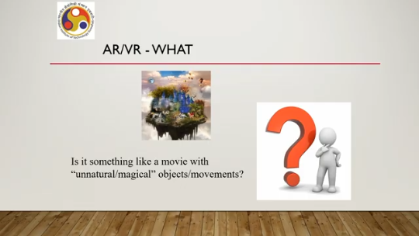
Now, when we talk of the terms AR, VR, or say MR, XR, to some immediately this type of magical environment comes to mind. But is it really the only thing in AR, VR, or say MR or XR? To some of us, when we use the terms AR, VR, MR, or XR, it may refer to video games, which is of course another type of fantastic world, imaginary world, rather unnatural world, but that is highly interactive compared to a movie. But when we say VR or when we say AR, do we refer to a video game only?
Similar to the previous one, when we say AR or VR, do we refer to a magical unnatural movie scene only or a movie experience only? We probably have seen some documentaries consisting of, say, animals or species which are now extinct, no longer around us. Say, for example, a documentary on dinosaurs, which probably we have experienced using a 3D or 4D movie theater. Many of you might have done that. So, is that VR or is that AR or is that MR or is that XR or neither of these? That is another.
So, for some of us, we perceive that 4D, 3D movie theaters where we are watching a documentary on some animals which no longer exist as examples of AR VR. But is that so? In fact, for the majority of us, whenever we use the term VR, probably this image comes to mind: that somebody, some user, wearing something called a headset as shown here. It is called a headset because it is worn on the head and it blocks our vision and we are transported to a virtual world which we can experience through the headset. In fact, this is the most common perception about VR: that somebody is wearing a headset and doing something in that virtual world.
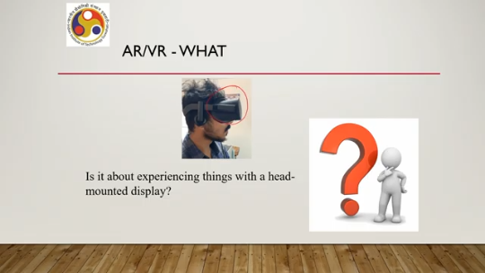
Similarly, many of us have played games like Pokemon Go, say for example, where you see the real world on your display screen, device screen, and at certain points. While viewing the real world, you get to see something virtual on the screen which does not exist in the real world. Say, for example, here on this road, this stretch of the road, you get to see a virtual object. Through your screen only, this object does not exist in the real world. So, what is this?
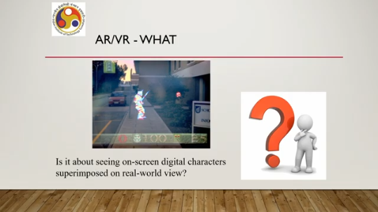
Is it AR or VR? Or rather, if I frame it differently, when I use the term AR/VR, do you think of this type of game? Does it immediately come to your mind that this refers to this type of game? Or do you think of something where we can see things in a different way? Say, for example, here, instead of seeing the leg, we can see the internal skeletal structure of the leg or the internal vein network.
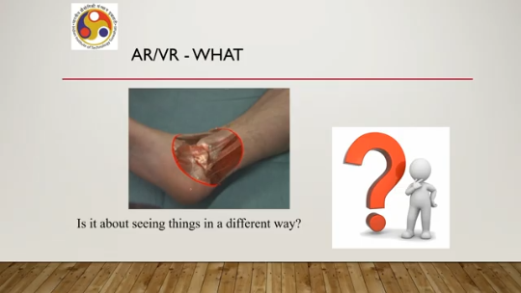
Or something like that, rather than seeing only the skin. Some of us may have seen this type of thing. So, when I say AR/VR, does it come to your mind that this type of seeing things in a different way refers to this technology? So, there are many such things that may come to our mind. Which one is referring to the actual technology, or do all of these refer to the actual technology?
As I said at the beginning, when I use the term VR or virtual reality or AR or augmented reality, some of you may feel that this refers to, say, somebody wearing a headset or somebody playing a game. Do you think of all of the things that we have just seen in the previous part of the lecture? Or do you think of only one or two or three of such things? That is the question.
So, in order to understand it in a better way, let us try to understand the terms. So, we started by saying that these terms have become very popular. Which were those terms? XR or Extended Reality, then AR, Augmented Reality, VR, Virtual Reality, and MR or Mixed Reality. Now, let us start with the first term: XR stands for Extended Reality.
XR is actually an umbrella term which encapsulates all the other terms that we are referring to, such as AR, VR, MR—everything. And one more important thing to note, which we will come back to at a later part of the course, is that XR encapsulates all immersive technologies. Note the term immersive. Immersive technologies like AR, VR, and MR. So, note here that XR is an umbrella term. XR is not referring to a specific technology. It is an umbrella term.
Covering all the technologies which are immersive in nature and generally which are known by these names: AR, VR, and MR. So, that is the first thing. Next is, there are two things in the definition of XR. That is, it refers to all immersive technologies, and the second thing is immersive. So, there is a very interesting thing here. When we are using the term XR, the term X can refer to two things. One is, it can be a part of the term 'extended' as you can see, or it can refer to a variable as mentioned here.
Now, this variable can take any value. In our case, it is taking three values: A for augmented reality, V for virtual reality, M for mixed reality. In fact, it can take many other values and those values, each of those values, form a technology. Say, for example, if I replace X with A, then it becomes AR. AR is a technology. If I replace X with M, it becomes MR. MR is a technology.
Now, that technology may exist now or it may come in the future. So, X refers to all present or future immersive technologies. That is another way of understanding X in XR. And what is immersive? That is a perceived experience through sensory organs which appears to be real. So, every day we are experiencing the real world.
Let me use the term 'real' within quotes. When I say immersive, that means we are in an environment, we are experiencing that environment through our sensory organs in such a way that we fail to distinguish between that environment and our real environment. We assume or we perceive that whatever we are experiencing is the real environment. If we are able to do that, that type of technology is immersive technology.
We will come back to this concept of immersion later in more detail. So, to sum up, extended reality refers to all present or future immersive technologies. So, it is an umbrella term and some of these immersive technologies are AR, VR, MR. The course title, of course, contains two terms AR and VR and we will see why MR is not specifically included in the course title. But before that, let me draw your attention to one more important concept that is called the reality-virtuality continuum.
At the end, I will talk about the reference from where this term has been taken. What does this refer to? So, it is essentially referring to a scale, a continuum. At one extreme of the scale is the real environment, nothing virtual there. At the other extreme is the virtual environment, so there is nothing real here.
So, completely virtual at one end, completely real at the other end. In between, there is an interval where at one end we have augmented reality, that means we are augmenting the real world with some digital content, virtual content and at the other end there is augmented virtuality. This is just the opposite of augmented reality where we are augmenting the virtual world with real world content. In augmented reality, we are augmenting the real world with virtual content.
In augmented virtuality, we are augmenting the virtual world with real world content. Say for example, here as you can see under augmented virtuality, you can see the human figure which is from the real world augmented within this virtual environment. Whereas, under augmented reality here, what we can see is that digital content, say this character, appearing in the real world setting. So, this in a very broad sense, this entire space between the two extremes, that is virtual environment and real environment, is called mixed reality.
But later on we will see different definitions of mixed reality. So, just to sum up, we have a way to visualize this reality-virtuality continuum that is in the form of a scale. At one end is the virtual environment, at the other end is the real environment. In between, there are different degrees of augmentation of the real environment with virtual content as well as the virtual environment with real content, and that entire space in between is broadly sometimes referred to as mixed reality. Now, let us try to seek the answer to why the interest.
So, remember at the beginning we asked a few questions about why we should know it. That was one of those questions. And let us try to understand why should we learn about this field? Why should we learn the technologies, learn the terms, their meanings, and so on? Why the interest?
In order to understand the interest, we have to start with some, we are going to start with some statistics. The statistics will reveal the importance from different angles. The first thing is it's a bit, say, three-year-old forecast that how the technology is going to affect different application domains. Say for example, this forecast is of course for the future made in 2022. Say, for example, the video game industry is going to have about 34% content related to these technologies.
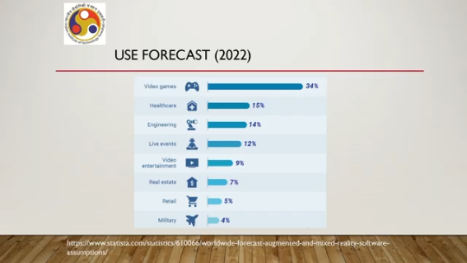
The healthcare industry is going to have about 15% of the content related to these technologies or built on these technologies. Engineering, 14%. Live events, say music concerts or so, 12%. Video entertainment, 9%. Real estate, 7%.
Retail, 5%. Military, 4%. Of course, these were from three years back. Now, the numbers might have changed toward the greater side, the larger side. And the statistics, of course, sometimes can hide many facts. For example, although military applications are likely to have a 4% component built on these technologies, since military budgets are huge, this 4% can translate to a huge amount of money.
So, you can see that there is likely to be a huge commercial interest in these technologies, which is likely to grow. How is it likely to grow? This is another study on the market size expected to be by 2030, starting from 2021. As you can see, these are all in US dollars. By 2030, it is likely to be around 860 billion dollars.
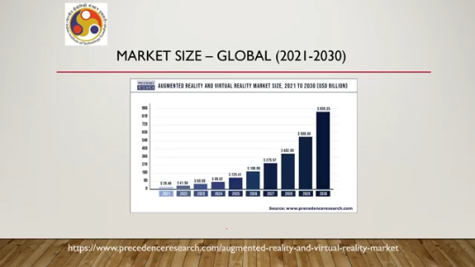
Whereas in 2021, it was around 20.5 billion dollars. You can see the huge growth. So, it has increased or it is likely to increase exponentially. Now among these markets, there is a market for software and a market for hardware. The hardware market is slightly larger, about 60% of the market size.
Software is slightly smaller, about 40%. And even in India, in our country, this industry is likely to grow significantly. In 2020, it was estimated to be at around 1.83 billion US dollars, whereas in 2027, it is expected to be around 14 billion dollars. So, the size is likely to increase significantly. So, all this refers to the fact that there is going to be significant demand.
Significant demand and growth potential. Significant demand in terms of what? In terms of the technology, because different applications are going to use it. So, we need to have the technology, we need to be developing the technology, and that demand is likely to grow heavily. There is another thing that aided this growth, of course, as you might all have heard of this term metaverse.
The term was, the term has been around for, say, about more than 30 years now, but it became very popular when Mark Zuckerberg used the term in a different context. Now, this term has stimulated and spurred the growth in the field heavily. Now, there is actually, when I say the term metaverse, it is not merely an application of virtual reality technology or mixed reality technology or augmented reality technology. We can look at it from different points of view. One broad point of view which is likely to spur the growth further is that we are going to reimagine the way humans interact with the digital world.
Right now, we are having a very flat type of interactions on flat screens, 2D interactions mostly and occasional 3D interactions and so on. In the Metaverse, we will be acting like we do in the real world. So, it is an all-around 3D world with a 3D environment and there we will be using our so-called quote-unquote natural way of interaction to interact with the digital content. That is a different way of looking at human-computer interaction which opens up many possibilities, many challenges, and we are likely to see further growth if this philosophy takes root, which as of now is taking root.
Now, of course, current technology is not yet that far gone. So, there is still significant scope to improve. We can improve the technology and make the overall idea of the metaverse a reality, and companies are investing in that conversion heavily. There are bottlenecks, many technological limitations, but hopefully with more investment, more research, those will be overcome and the growth potential is going to be huge. And the growth potential will be there in both hardware and software. So, what does that point to?
That points to the fact that we will be needing more knowledgeable and skilled manpower. So, that is going to open another avenue. In fact, this area is one of the major emerging areas identified by many national governments along with, say, AI, large language models, generative AI, drones, nanomaterials and so on. So, it is going to be useful if you invest in it, if you learn the skills, and if you are able to develop and deploy systems based on this technology. So, it is an emerging field with potential and it will be helpful if you learn this field. So, that is the why part. Why should we learn? Now, with that, we have answered one question. The other questions we will answer as we progress.
And before we go to the next lecture, let me just briefly talk about this course: what we are going to see, what we are going to learn, and what our objective is. So, the broad objective of the course is to learn about this field of virtual reality and augmented reality, including allied concepts that are part of the field that everybody should know if he or she wishes to master the field and get a comprehensive idea on how to develop and deploy AR VR systems. Those are the broader objectives of the course. Now, in order to achieve this broader objective, where shall we focus?
We will focus on basic understanding, basic understanding of all the relevant concepts, A theoretical background that is required to build a foundation in this field and then practical knowledge on development and deployment. So, we will be using some case studies which have used some game engines and SDKs to explain how to develop and deploy such technologies. Under the basic understanding, what are we going to learn? We are going to learn what these systems are, that is the meaning of these terms and what they refer to, defining characteristics of these systems, what are the core concepts that we should be aware of
How to distinguish between the technologies? Remember that is one of the questions we asked earlier. Do they refer to the same technology or different technologies? If they are different technologies, how are they different? So, we are going to find answers to those questions when we go through the basic understanding part of the course.
Another important thing that we will learn is how our senses influence the use of the technology or system. That is how we get the desired experience using our senses. That requires some understanding of our cognitive and psychological side, which we will briefly cover, which is one of the foundational concepts that any developer should be aware of. In the theoretical background, we shall learn about concepts relevant to understanding and developing the technology or systems. It spans from understanding how to build interactive software to how to build interactive VR or AR systems to understanding how the software works, what the components are, how the hardware works, what the different hardware technologies available are, how to design and implement interactions in such environments, and so on and so forth.
We will be explaining these concepts in terms of that example, that case study that was mentioned earlier. That use case will be on a digital heritage preservation project which resulted in a virtual reality system which we will be going through and try to relate whatever we are learning with the system so that the learning becomes easier. So with that, we have come to the conclusion of this first lecture. To sum up, in this lecture, we talked about a few concepts, namely XR, AR, MR, VR. And we have seen what these terms refer to.
Just to recollect, XR refers to the term extended reality. Intuitively, it refers to extending the reality by some means. Systematically, or rather systemically, it refers to using systems to augment our reality or replace our perception of reality rather. So, we have seen that concept of the reality-virtuality continuum, where one end is the complete replacement of reality with virtual reality systems, the other end is the complete replacement of virtuality with the entirely real world; in between there are these extended reality or augmented reality concepts which are broadly referred to as mixed reality. These terms will be more precisely defined in subsequent lectures.
So, here it is just meant to give you a broader idea, but more precise definitions we will deal with later. And we have also seen why learning these concepts is important, particularly as these fields are one of the major emerging technology areas recognized by industry, academia, and governments. So, soon we are going to require huge manpower, skilled manpower in this area. So, learning the skills, learning the foundations would certainly be helpful for future opportunities. And in this course, we will be learning basic concepts, foundational concepts, and practical ways to develop and deploy such systems using one example.
That example is a use case of a virtual reality system related to a digital heritage preservation project. That is the overall idea, the overall objective of this course, and the overall course content. So, that reality-virtuality continuum that we have mentioned earlier was taken from this reference. Paul Milgram and Fumio Kishino published in 1994 one seminal paper, A Taxonomy of Mixed Reality Visual Displays. Now, this is one of the earliest papers published in this field, which influenced shaping up the area significantly.
So, I strongly recommend that if you can, all of you try to go through the content of this paper, you will realize how it looked like in those early days, how researchers viewed this field in those early days. With that, I would like to conclude this introductory lecture. Thank you. I hope you have enjoyed the lecture. Happy learning.
Looking forward to seeing you in the subsequent lectures. Thank you and goodbye.

